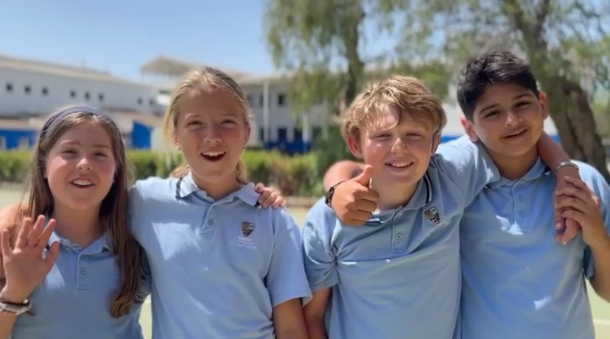

BIC Sa Porrassa
Primary Curriculum
2025-26

Contents
Introduction 3
The Primary Curriculum 4
Key Stage 1 (Age 5-7) 6
About Key Stage 1 6
Subjects at Key Stage 1 7
Example of a KS1 Timetable 8
The Key Stage 1 Curriculum 9
Key Stage 2 (Age 7-11) 10
Subjects at Key Stage 2 11
Example of a KS2 Timetable 12
The Key Stage 2 Curriculum 13
Homework at BIC 14
PSHE, RSE and Careers at BIC 15
Extracurricular at BIC 17

Introduction

At BIC, our curriculum is grounded in the aims and structure of the English National Curriculum, while being thoughtfully adapted to reflect the needs of our pupils and our distinctive context. We are proud to offer the best of a traditional British education, enriched by innovative approaches that support every child’s development.

We provide a broad, balanced and ambitious curriculum that fosters secure knowledge, essential skills, and a genuine love of learning. Our approach promotes curiosity, creativity and critical thinking, while supporting children’s academic, social, emotional and physical development.

While we embrace innovation—drawing on educational research and making effective use of technology—we also value the time-tested methods that have consistently supported high standards of achievement. By balancing tradition with forward-thinking practice, we ensure that our pupils are well-prepared for the next stage of their education and for life.

We recognise that every child is unique. Our curriculum is inclusive and responsive to individual needs, ensuring all learners are supported and appropriately challenged. We aim to nurture confident, independent and resilient learners who are ready to make a positive contribution to society.

At the heart of our curriculum are our school values: Excellence, Respect, Responsibility, Integrity, and Compassion. These values underpin every aspect of school life and help us create a safe, inclusive and aspirational learning environment in which all pupils can thrive. In addition, we actively promote the fundamental British values of democracy, the rule of law, individual liberty, mutual respect, and tolerance, helping pupils to become thoughtful, informed and responsible citizens.


This document outlines the curriculum we offer across the primary phase and explains how we support children to meet their full potential. We hope it provides a clear picture of the rich, well-rounded education that every child experiences at BIC.
Adam Fairless
Head of Primary

The Primary Curriculum

To ensure a clear, coherent and ambitious curriculum for all pupils, we have developed Key Progression Documents across English, Mathematics, Science, and the Foundation Subjects. These documents map out the essential knowledge, skills and understanding that pupils are expected to secure at each stage of their primary education.

The progression frameworks provide:
- Clarity about what should be taught and learned year by year.
- Consistency in expectations across classes and key stages.
- Support for teachers in planning, assessment and identifying next steps for learning.

By setting out carefully sequenced learning pathways, the documents ensure that pupils build securely on prior knowledge, make strong connections across subjects, and are well-prepared for the next stage of their education.

English
English (speaking, reading and writing) is integral to the whole curriculum. At BIC we intend to provide a wide range of learning experiences, giving children the opportunity to develop reading strategies and to read for pleasure and purpose. We will give the children the opportunity to write in a range of styles; speak confidently in a range of contexts and develop focused listening skills. We will help our pupils to express themselves creatively and imaginatively and to understand how language works by looking at its patterns, structures and origins. We aim to foster a strong culture of reading and writing.

Writing Progression Map 2025-26 Grammar Overview 2025-26

Phonics and Early Reading
BIC teaches reading through a bespoke programme following the systematic and synthetic phonics progression, Letters and Sounds, blended with the best elements and teaching practices of other successful phonic programmes. We start teaching phonics in Year 1 and following the letters and sound progression building on children´s growing knowledge of the alphabetic code, mastering phonics to read and spell as they move through school.

As a result, children can tackle any unfamiliar words, vocabulary and reading for meaning both for pleasure and purpose. We also model the application of the alphabetic code through phonics in shared reading and writing, both inside and outside of the phonics lesson and across the curriculum. We have a strong focus on language development for pupils to enhance the crucial skills for reading and writing.

Progression in Phonics

Mathematics

At BIC we follow the White Rose Maths scheme to ensure a coherent and progressive approach to the teaching of mathematics. The scheme is carefully mapped out across the year, providing full coverage of the National Curriculum and enabling pupils to develop a deep and secure understanding of key mathematical concepts. Through small, sequenced steps, pupils build fluency, reasoning and problem-solving skills, ensuring strong foundations for future learning.

Long Term Plan Y1-Y6 White Rose Maths Key Objectives Calculations Policy

Science and the Foundation Subjects

Science and the foundation subjects are mapped out carefully across the year to provide pupils with a broad, balanced and enriching curriculum. Each subject is planned in line with the National Curriculum, ensuring that knowledge and skills are sequenced progressively from Year 1 through to Year 6. This approach allows pupils to build securely on prior learning, make meaningful connections across subjects, and deepen their understanding over time.

Where appropriate, these subjects are taught through carefully designed thematic topics. This thematic approach provides meaningful contexts for learning, helps pupils to see links between different areas of the curriculum, and enhances engagement and enjoyment.

Our progression maps set out the essential knowledge, key vocabulary and disciplinary skills that pupils need to master at each stage. This structured approach supports consistency in teaching, ensures full curriculum coverage, and prepares pupils effectively for the next phase of their education.

BIC Curriculum Plan 2025-26

Key Stage 1 (Age 5-7)

About Key Stage 1
Key Stage 1 (KS1) marks the first formal stage of the English National Curriculum, covering Years 1 and 2 for children aged 5 to 7. It builds on early developmental learning and introduces a more structured approach to education; while maintaining a nurturing, engaging environment suited to young children.

At BIC, our KS1 curriculum draws on the best of a traditional British education and is shaped by our international context. It places a strong focus on developing secure foundations in reading and phonics, writing, mathematics, Science, Spanish, Catalan (Year 2) while ensuring breadth through subjects such as PSHE (Personal Social and Health Education), humanities (history and geography), art, music, PE, and computing. Phonics and early reading are prioritised to ensure fluency and confidence from the start.

Teaching is carefully sequenced and responsive, designed to support all learners and promote independence, curiosity, and resilience. Alongside academic development, we place equal importance on pupils’ personal, social, and emotional growth.

Our school values—Excellence, Respect, Responsibility, Integrity, and Compassion—are embedded throughout the curriculum and daily routines, shaping attitudes to learning and behaviour from the earliest years.

Key Stage 1 at BIC provides the essential building blocks of a high-quality education. By combining the rigour of the English National Curriculum with a child-centred, values-driven approach, we create a learning environment where every child can thrive academically, socially, and emotionally.

Subjects at Key Stage 1

Subject | Classes per week
English | 4
Phonics | 3
Mathematics | 5
Science | 2
Spanish | 4
Catalan*  All Spanish citizens by law are required to study Catalan from Year 2. We have scheduled these to still allow access to the rest of our core curriculum | 3
PSHE / Assembly | 2
Humanities | 2
Music | 1
Computing | 1
Art | 1
Physical Education | 2
Total | 30

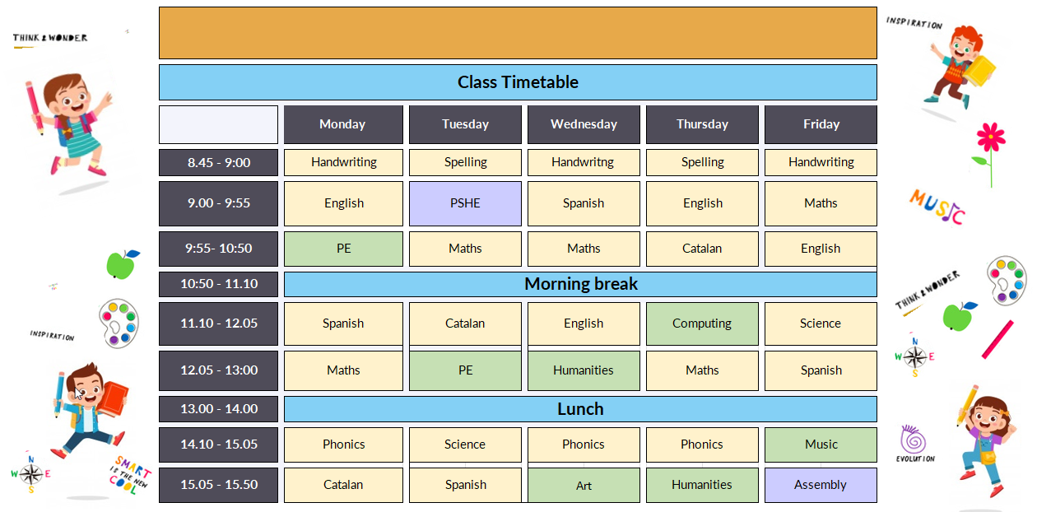
Example of a KS1 Timetable

The Key Stage 1 Curriculum
In the links below you will find a brief description of the content covered in each subject for each year group throughout the year. Please note that these Curriculum Overviews are in the process of being updated for the 2025-26 Curriculum and will be published online.

Subject Overviews
Year 1 | Year 2
Term 1  Term 2  Term 3 | Term 1  Term 2  Term 3

Key Stage 2 (Age 7-11)

About Key Stage 2

Key Stage 2 (KS2) covers Years 3 to 6, for pupils aged 7 to 11. It is a critical stage in a child’s development, building on early learning and preparing pupils for the transition to secondary education. During this phase, children deepen their knowledge, develop greater independence, and take increasing responsibility for their learning.

At BIC, our KS2 curriculum follows the English National Curriculum, offering breadth, balance and challenge across subjects. Pupils study English, mathematics, science, Spanish, Catalan, PSHE (Personal Social and Health Education), humanities (history and geography), art, music, computing, PE, and modern foreign languages (German and French), alongside regular opportunities for enrichment and cross-curricular learning.

We draw on the best of a traditional British education—emphasising subject rigour, secure progression, and high expectations—while also responding to the needs of our diverse international community. Teaching is carefully sequenced to support knowledge retention, critical thinking, and problem-solving, as well as collaborative and independent learning.

Phonics, reading, and writing continue to be priorities, with a focus on fluency, comprehension, and confident communication. Mathematics is taught with an emphasis on conceptual understanding, reasoning, and application. Across all subjects, pupils are encouraged to think deeply, ask questions, and reflect on their progress.

Personal development is central to our approach. Pupils build resilience, empathy, and responsibility, supported by our core values: Excellence, Respect, Responsibility, Integrity, and Compassion. These values are embedded throughout the curriculum and school life, guiding behaviour, relationships, and attitudes to learning.

Key Stage 2 at BIC provides the essential building blocks of a high-quality education. By combining the rigour of the English National Curriculum with a child-centred, values-driven approach, we create a learning environment where every child can thrive academically, socially, and emotionally.

Subjects at Key Stage 2
Subject | Classes per week
English | 5
Mathematics | 5
Science | 2
Spanish | 4
Catalan*  All Spanish citizens by law are required to study Catalan from Year 2. We have scheduled these to still allow access to the rest of our core curriculum | 3
Modern Foreign Languages  German and French optional in Yr 6. | 2
PSHE / Assembly | 2
Humanities | 2
Music | 1
Computing | 1
Art | 1
Physical Education | 2
Total | 30

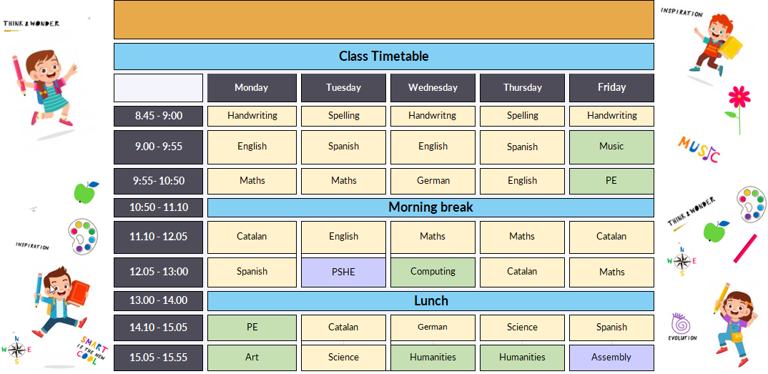
Example of a KS2 Timetable

The Key Stage 2 Curriculum
In the links below you will find a brief description of the content covered in each subject for each year group throughout the year. Please note that these Curriculum Overviews are in the process of being updated for the 2025-26 Curriculum and will be published online.

Subject Overviews
Lower Key Stage 2 |  | Upper Key Stage 2
Year 3 | Year 4 | Year 5 | Year 6
Term 1  Term 2  Term 3 | Term 1  Term 2  Term 3 | Term 1  Term 2  Term 3 | Term 1  Term 2  Term 3

Homework at BIC
At BIC, homework in the primary phase is designed to support classroom learning, promote independence, and strengthen the partnership between home and school. We take a purposeful and age-appropriate approach, ensuring that tasks are manageable, meaningful, and aligned with pupils’ developmental needs.
Children are typically set two tasks each week—one focused on mathematics and another linked to English or humanities. These activities are intended to consolidate learning, reinforce key skills, and encourage the development of good learning habits.
Reading at home is a central part of our homework approach. We expect pupils to read frequently—ideally every day—either with an adult or independently, depending on their age and ability. Reading aloud, being read to, and talking about books all play a vital role in building fluency, comprehension, and a lifelong enjoyment of reading.
We also place strong value on spoken language and discussion. Talking about the world around us, school learning, and everyday experiences helps to develop vocabulary, reasoning, and confidence in communication. We encourage families to engage in regular conversations with their children to support learning across all subject areas.
Homework tasks are shared in class and made available on Canvas, our online learning platform. This system provides a clear and consistent structure for communicating assignments and sharing resources. Guidance is provided at the start of each academic year to support parents and carers in accessing and using the platform confidently. Teachers use Canvas to monitor engagement, provide feedback, and respond to questions as needed.
Our approach to homework reflects our broader educational aims: to nurture independent learners, foster home-school collaboration and extend learning beyond the classroom. By prioritising reading, encouraging meaningful discussion, and setting focused weekly tasks, we aim to make homework a valuable and positive experience for every pupil.

PSHE, RSE and Careers at BIC

PSHE (Personal, Social, Health and Economic education), alongside RSE (Relationships and Sex Education) and Careers guidance, forms a core part of the holistic development of our students. These subjects ensure that young people gain the knowledge, skills, and attributes they need to navigate life’s opportunities and challenges, to stay healthy and safe, and to be prepared for life and work beyond school.

At BIC we are committed to ensuring that our curriculum meets and exceeds UK government requirements in these areas. We have mapped out a 13-year PSHE, RSE and Careers journey from Year 1 through to Sixth Form, ensuring that all content is taught in a carefully sequenced, age-appropriate way. This mapping is explicitly aligned with government-approved roadmaps, consulting the PSHE Association Programme of Study, statutory RSE guidance, and the Gatsby Benchmarks for Careers.

We deliver this provision whilst remaining sensitive to our local context here in Mallorca and responsive to the diverse international backgrounds of our students. Our curriculum reflects both the realities of life in our community and the global perspectives necessary for students who may continue their education or careers in a wide variety of countries and cultures.

Whilst PSHE is taught as a discrete subject, in addition, key themes are woven into other aspects of our curriculum, to make the learning experience more relevant and meaningful for students. (For instance, students may also learn about the potential dangers of alcohol as part of their science course, and engage in important conversations about relationships through the study of relevant literary texts in their English lessons.) This integration allows students to further explore PSHE themes within the context of their wider academic studies, enabling a deeper understanding and practical application of the knowledge and skills they acquire.

We also recognise that the cultural landscape is constantly evolving, and with it the needs of young people. Our PSHE, RSE and Careers curriculum is therefore regularly reviewed and refined to remain current, relevant and impactful. A key part of this process is our strong commitment to parental consultation. We welcome and value parent feedback and input on the content of our PSHE programme, ensuring that it reflects the values and expectations of our school community as well as statutory guidance. In addition, we actively encourage parental participation in our Careers programme, drawing on the diverse expertise, industries and backgrounds represented within our parent body to enrich and broaden the opportunities available to our students.

Through this integrated, progressive and consultative approach, every student has access to a comprehensive, government-aligned programme that balances personal wellbeing, relationships, and preparation for the world of work. In doing so, we equip our students not only with academic knowledge, but also with the resilience, values, and life skills needed to thrive as responsible, confident and compassionate global citizens.

Our PSHE curriculum reflects our school’s aim and ethos and encourages respect for other people. We pay particular regard to the protected characteristics of age, disability, gender reassignment, marriage and civil partnership, pregnancy and maternity, race, religion or belief, and sex and sexual orientation precludes the promotion of partisan political views in the teaching of any subject in the school. Where political issues are taught, we ensure students are offered a balanced presentation of opposing views.

In addition, we promote the spiritual, moral, social, and cultural development of our students. Our PSHE curriculum actively promotes the fundamental British values of democracy, the rule of law, individual liberty, and mutual respect of those with different faiths and beliefs. We actively promote principles that enable pupils to develop their self-knowledge, self-esteem and self-confidence, to distinguish right from wrong and to respect the civil and criminal law of England.

One of our school values is responsibility. We encourage pupils to accept responsibility for their behaviour, show initiative and understand how they can contribute positively to the lives of those living and working in our locality and to society more widely. PSHE enables pupils to acquire a broad general knowledge of and respect for public institutions and services in England and for the responsibilities of citizenship in Spain.

Another of our school values is respect. We aim to have harmony between different cultural traditions, by enabling pupils to acquire an appreciation of their own and other cultures. We encourage respect for other people, paying particular regard to the protected characteristics set out in the Equality Act 20102 as well as respect for democracy and support for participation in the democratic processes, including respect for the basis on which the law is made and applied.

By following the latest advice from the UK Ministry of Education and integrating PSHE within our curriculum, we strive to provide our students with the necessary tools and knowledge to navigate the complexities of life. We believe that by delivering these essential lessons in a relevant and interconnected manner, we empower students to make informed decisions, develop strong personal values, and become responsible citizens who contribute positively to society.

Extracurricular at BIC

For full details of our extensive extra-curricular activities on offer after-school, please see our ECA brochure. This will be emailed to all parents by our ECA coordinator during the first Half Term.

